**Problem Set 3**

This problem set covers material from classes 6 and 7, including material from OIS sections 3.1 and 3.2. It makes use similar data to that we discussed in class. Partial credit may be given for answers that are correct in part, but not in full. This problem set is due on Gradescope by Wednesday September 15, 2021 at 11:59 PM.

**Part I: Probability and the Michigan 8th Election in 2018 (30 pts.)**

The questions in this section will focus on probability and the *New York Times* Live Poll of the Michigan 8th District Election that we conducted in class. As a reminder, this is what the poll looked like as voters responded.

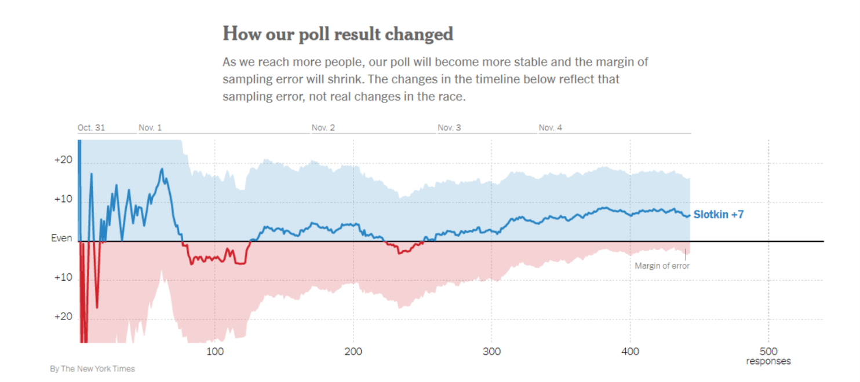

1. In your own words, please restate what concept the above chart of polling responses illustrates and how it illustrates it. What would you expect the chart to look like if 500 more voters responded? (6 pts.)
2. While 447 respondents answered the survey, Siena made 40,230 calls to individuals in the district. People can either be responders or non-responders. (24 pts.)
   1. What is the probability that a randomly selected number that Siena called resulted in a survey response? Please show your work in calculating this. (4 pts.)
   2. What is the probability that a randomly selected person who Siena called did **NOT** respond to the survey? How can you use your answer from part a to answer this question and what rule does this illustrate? (6 pts.)
   3. What is the probability that a randomly selected person who Siena called is a survey responder **OR** a survey non-responder? What is the probability that they are a survey responder **AND** a survey non-responder? Why is this the case? (6 pts.)
   4. Imagine that you are an interviewer making calls for this survey and are winding up your shift and plan to make 3 more calls before leaving for the day. Assuming independence between calls, what is the probability that all three will not answer the survey? Please show your work in answering this question. (4 pts.)
   5. Imagine that you made these three calls and none of the people answered the survey. You decide to make one more call before finishing for the day. Are you “due” for a survey responder? Why or why not? (4 pts.)

**Part III: The 2020 Election and the Location of NFL Teams (22 pts.)**

This section uses data on the 2020 US Presidential Election and the location of NFL teams. Two pieces of the information are useful for this problem: In 2020, Joe Biden and Donald Trump each won 25 states. There are 23 states that have at least one NFL team located inside their borders.

1. I would like you to consider the probability of various outcomes when it comes to a state’s vote in the 2020 presidential election and whether it has an NFL team. (22 pts.)
   1. The below probability distribution shows the four possible outcomes. Please fill in the two outcomes that are blank. Please show all of your work. (8 pts.)

|  |  |  |  |
| --- | --- | --- | --- |
| Biden, NFL Team | Biden, No NFL Team | Trump, NFL Team | Trump, No NFL |
| 30% |  |  | 34% |

* 1. Here I gave you the number of states that have an NFL team. How could you find the number of states without an NFL team using just the information in this problem? What does NFLc represent here? (4 pts.)
  2. Looking at the above table, if you knew which presidential candidate won a state in 2020, would that help you guess if the state had an NFL team? Please explain your reasoning. Put differently, if I told you that Donald Trump won a state, what would be your guess for whether they had an NFL team? (4 pts.)
  3. Would it be reasonable to conclude that having an NFL team causes a state to vote for a particular candidate? Are there any other factors at play that might be confounding variable? (Hint: Google the location of NFL teams and glance at the NYT map of 2020 presidential results if you are not an NFL fan and/or political junkie; 6 pts.)

**Part IV: Probability and the 2020 Election (36 pts.)**

1. Currently, 27 states have ["right-to-work"](https://www.ncsl.org/research/labor-and-employment/right-to-work-laws-and-bills.aspx) laws, which tend to be associated with lower rates of unionization (you can read more about what these laws entail by going to the link above). Here, we are going to examine the probabilities associated with states having right-to-work laws and their support for each presidential candidate in 2020. The below 2 by 2 table from *R* shows presidential support and right-to-work status. (36 pts.)

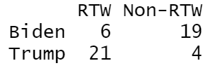

* 1. If you randomly select a state, what is the marginal probability of a state having a right-to-work law? Please show your work. (4 pts.)
  2. If you randomly select a state, what is the joint probability of the state having a right-to-work law *and* voting for Biden? Please show your work. (4 pts.)
  3. What is the conditional probability of having a right-to-work law **given** that a state voted Biden for President? Please show your work. (4 pts.)
  4. Does having a right-to-work law and voting Democratic for president appear to be independent? (Hint: set the probability of voting Democratic for president as P(B).) Based on this, use the general multiplication rule to find the probability of having a right-to-work law and voting Democratic for President and discuss how this compares to the probability if they were independent. Please show your work. (8 pts.)
  5. Probability trees are a good way to organize outcomes. Please fill in this probability tree. (8 pts.)

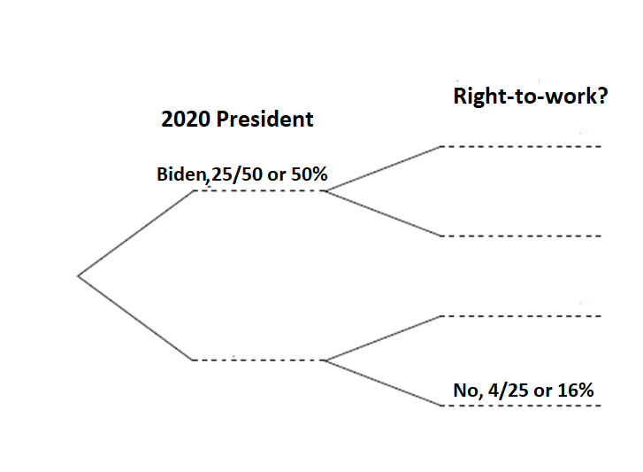

* 1. Using the probabilities you filled in above, please calculate the joint probabilities that apply to the scenarios related to each secondary branch. (Note: you can either fill them in above to the right of what you already filled in or put them here, but if you place them here, please note which secondary branch scenario they apply to below.) Please show your work. (8 pts.)

**Part V: Bayes’ Rule (12 pts.)**

1. In class, we also discussed whether a state is part of the “Blue Wall.” 18 states are part of the “Blue Wall.” (12 pts.)
   1. The probability of having a right-to-work law given that a state is in the Blue Wall is 11.11%. (16/18 states). What is the probability of a state being in the Blue Wall given that it has a right-to work law? Use Bayes’ Rule and please show your work (6 pts.).
   2. The probability that a state has an NFL team given that it is in the Blue Wall is 61.11%. What is the probability of a state being in the Blue Wall given that it has an NFL team? Use Bayes’ Rule and please show your work (6 pts.)